Computer Language Coding Concepts

Class Inheritance
Class inheritance is the traditional form of inheritance: one class takes over all characteristicts of another class. This is displayed as follows:

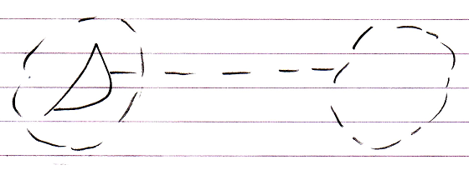

The second class merges with the first class. The first class has an interface that delegates its implementation to the second class.

Author & Copyright: Jan-Joost van Zon Date: May 18, 2010 – July 17, 2010 Location: Oosterhout, The Netherlands Status: Finished

